Lesson 24: Applications of Systems of Equations and Inequalities

Classwork

Opening Exercise

In Lewis Carroll’s *Through the Looking Glass,* Tweedledum says, “The sum of your weight and twice mine is $361$ pounds.” Tweedledee replies, “The sum of your weight and twice mine is $362$ pounds.” Find both of their weights.

**Example**

Lulu tells her little brother, Jack, that she is holding $20$ coins, all of which are either dimes or quarters. They have a value of $\$4.10$. She says she will give him the coins if he can tell her how many of each she is holding. Solve this problem for Jack.

Exploratory Challenge

* 1. At a state fair, there is a game where you throw a ball at a pyramid of cans. If you knock over all of the cans, you win a prize. The cost is $3$ throws for $\$1$, but if have you an armband, you get $6$ throws for $\$1$. The armband costs $\$10$.
     1. Write two cost equations for the game in terms of the number of throws purchased, one without an armband and one with.
     2. 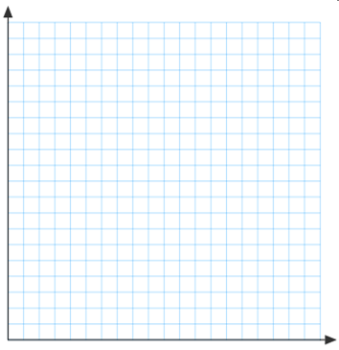Graph the two cost equations on the same graph. Be sure to label the axes and show an appropriate scale.
     3. Does it make sense to buy the armband?
  2. A clothing manufacturer has $1,000 yd.$ of cotton to make shirts and pajamas. A shirt requires $1 yd.$ of fabric, and a pair of pajamas requires $2 yd.$ of fabric. It takes $2 hr.$ to make a shirt and $3 hr.$ to make the pajamas, and there are $1,600 hr.$ available to make the clothing.
     1. What are the variables?
     2. What are the constraints?
     3. Write inequalities for the constraints.



* + 1. Graph the inequalities and shade the solution set.
    2. What does the shaded region represent?
    3. Suppose the manufacturer makes a profit of $\$10$ on shirts and $\$18$ on pajamas. How would it decide how many of each to make?
    4. How many of each should the manufacturer make, assuming it will sell all the shirts and pajamas it makes?

Problem Set

1. Find two numbers such that the sum of the first and three times the second is $5$ and the sum of second and two times the first is $8$.
2. A chemist has two solutions: a $50\%$ methane solution and an $80\%$ methane solution. He wants $100 mL$ of a $70\%$ methane solution. How many $mL$ of each solution does he need to mix?
3. Pam has two part time jobs. At one job, she works as a cashier and makes $\$8$ per hour. At the second job, she works as a tutor and makes $\$12$ per hour. One week she worked $30$ hours and made $\$268$. How many hours did she spend at each job?
4. A store sells Brazilian coffee for $\$10$ per $lb.$ and Columbian coffee for $\$14$ per $lb$. If the store decides to make a   
   - blend of the two and sell it for $\$11$ per $lb.$, how much of each type of coffee should be used?
5. A potter is making cups and plates. It takes her $6 min.$ to make a cup and $3 min.$ to make a plate. Each cup uses $\frac{3}{4} lb.$ of clay, and each plate uses $1 lb$. of clay. She has $20 hr.$ available to make the cups and plates and has $250 lb.$  
    of clay.
   1. What are the variables?
   2. Write inequalities for the constraints.
   3. Graph and shade the solution set.
   4. If she makes a profit of $\$2$ on each cup and $\$1.50$ on each plate, how many of each should she make in order to maximize her profit?
   5. What is her maximum profit?